

**Law of Demand and its Existence.**

Submitted by:

Ajmie Tabassum ID:191002279,

Md Shamiul Hossain ID: 191002015,

Abu Arefin Aroop ID:202002007,

Fardin Amin Arpon ID: 201002243,

Computer Science and Engineering, Green University of Bangladesh

Course Code: GED-301

Course title: Engineering Economics

Course Teacher: Md. Fakhrudoza Bari (Assistant professor)

Due Date: August 31,2021

**The Law of Demand**

The law of demand is one of the most fundamental concepts in economics. It works with the [law of supply](https://www.investopedia.com/terms/l/lawofsupply.asp) to explain how market economies allocate resources and determine the prices of goods and services that we observe in everyday transactions.

The law of demand states that quantity purchased varies inversely with price. In other words, the higher the price, the lower the quantity demanded. This occurs because of [diminishing marginal utility](https://www.investopedia.com/terms/l/lawofdiminishingutility.asp). That is, consumers use the first units of an economic good they purchase to serve their most urgent needs first, and use e ach additional unit of the good to serve successively lower-valued ends

**Description**

Law of demand explains consumer choice behavior when the price changes. In the market, assuming other factors affecting demand being constant, when the price of a good rises, it leads to a fall in the demand of that good. This is the natural consumer choice behavior. This happens because a consumer hesitates to spend more for the good with the fear of going out of cash.

|  |
| --- |
|  |

The above diagram shows the demand curve which is downward sloping. Clearly when the price of the commodity increases from price p3 to p2, then its quantity demand comes down from Q3 to Q2 and then to Q3 and vice versa

**Simple Explanation of the Law of Demand**

The Law of Demand tells us that if more people want to buy something, given a limited supply, the price of that thing will be bid higher. Likewise, the higher the price of a good, the lower the quantity that will be purchased by consumers.

**Importance of law of Demand**

Together with the Law of Supply, the Law of Demand helps us understand why things are priced at the level that they are, and to identify opportunities to buy what are perceived to be underpriced (or sell overpriced) products, assets, or securities. For instance, a firm may boost production in response to rising prices that have been spurred by a surge in demand

**Exceptional Law of Demand**

From the conventional law of demand, we know that higher the price, lower the quantity demanded.

But there are some exceptions, where price doesn’t affect in demand, in others words, the price increase, the quantity demand will also be increasing.

**Some types of exceptions**

### 1. Giffen Goods

### 2. Veblen Goods

### 3. The expectation of Price Change

### 4. Necessary Goods and Services

### 5. Change in Income

**Geffen Goods**

The unique characteristic of Giffen goods is that as its price increases, the demand also increases. And this feature is what makes it an exception to the law of demand.

For example: Rice, is our main diet, when the price of rice increased, people spent less on luxury foods such as meat and bought more rice to stick to their diet. So as the price of rice increased, so did the demand, which is a complete reversal of the law of demand.

**Veblen Goods**

There are certain goods that become more valuable as their price increases. If a product is expensive, then its value and utility are perceived to be more, and hence the demand for that product increases.

And this happens mostly with precious [metals](https://www.toppr.com/guides/chemistry/materials-metals-and-non-metals/metals-and-non-metals/) and stones such as gold and diamonds and luxury cars such as Tesla. As the price of these goods increases, their demand also increases because these products then become a status symbol.

### The expectation of Price Change

There are times when the price of a product increases and market conditions are such that the product may get more expensive. In such cases, consumers may buy more of these products before the price increases any further. For instance, in recent times, the price of onions had increased to quite an extent. Consumers started buying and storing more onions fearing further price rise, which resulted in increased demand.

There are also times when consumers may buy and store commodities due to a fear of shortage. Therefore, even if the price of a product increases, its associated demand may also increase as the [product](https://www.toppr.com/guides/business-studies/marketing/product/) may be taken off the shelf or it might cease to exist in the market.

### Necessary Goods and Services

Another exception to the law of demand is necessary or basic goods. People will continue to buy necessities such as medicines or basic staples such as sugar or salt even if the price increases. The prices of these products do not affect their associated demand.

### Change in Income

Sometimes the demand for a product may change according to the change in income. If a household’s income increases, they may purchase more products irrespective of the increase in their price, thereby increasing the demand for the product. Similarly, they might postpone buying a product even if its price reduces if their income has reduced. Hence, change in a consumer’s income pattern may also be an exception to the law of demand.

**Graph of exceptional in law of demand**

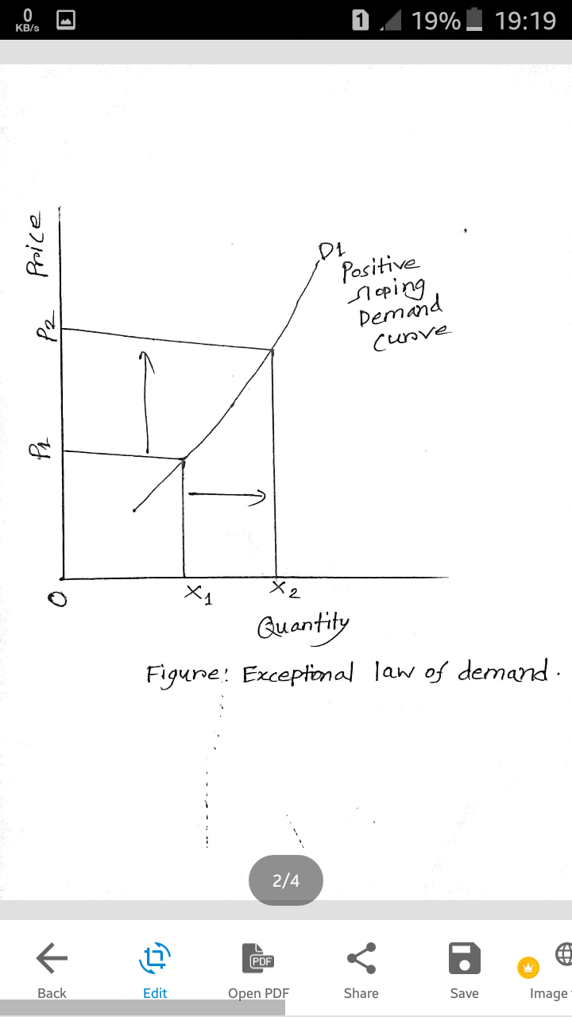

In the graph we see that positive slope of demand curve,

that means the price is increasing as well as the quantity demand also increasing.

**Demand function**

Demand function is what describes a relationship between one variable and its determinants. It describes how much quantity of goods is purchased at alternative prices of good and related goods, alternative income levels, and alternative values of other variables affecting demand.

In the short run, the demand function states the relationship between the aggregate demand of a product and the price of the product, while keeping other determinants of demand at constant.

**The demand function can be expressed as follows:**

Dx = f (Px)

Where, Dx= dependent variable

Px = independent variable

**Types of demand Function (basis of time periods):**

**i. Linear Demand Function:**

Refers to the demand function in which the change in dependent variable remains constant for a unit change in the independent variable, regardless the level of the dependent variable. In the linear demand function, AD/AP is constant and the resultant demand curve is a straight line.

**Price function can be obtained with the help of demand function by the following equation:**

Px = a – Dx/ b

Px = a/b-(1 /b) Dx

Let us assume that a/b = a1 and 1/b = b1, then the price function would be:

Px = a1 – b1Dx

**ii. Non-Linear Demand Function:**

Refers to the demand function in which the dependent variable keeps changing with the change in the independent variable. In the non-linear demand function, the slope of the curve changes throughout the curve.

**The equation for non-linear demand function is as follows:**

Dx = a (Px)-b and

Dx = (a/Px + c)-b Where, a or b or c >0

**iii. Multivariate or Dynamic Demand Function:**

Expresses a relationship between a dependent variable, such as demand, and more than one independent variable, such as price and income. In the long-run, individual or market demand cannot be derived by using only one variable because other determinants are not constant and they do affect the demand for a product. In addition, in long-run, demand for a product can be determined by the composite demand of all the determinants affecting the demand for a product.

**The multivariate demand function can be expressed as follows:**

Dx = f (Px, M, Py, Pc, T, A)

Where, Px = Price;M = Consumer’s income

Py = Price of substitutes

Pc = Price of complementary goods

T = Consumer’s taste

A= Advertisement expenditure

**If the relationship between the demand and its determinants is a straight or linear line, then demand function can be expressed as follows:**

Dx = a + b Px + cM + dPy + ePc + g T + jA

Where, a = constant and b, c, d, e, g, and j = coefficients of relation between demand and its determinants.

**Prove of Law of Demand with Schedule and Graph**

Demand schedule refers to a tabular representation of the relationship between price and quantity demanded. It demonstrates the quantity of a product demanded by an individual or a group of individuals at specified price and time.

**Types of demand Schedule**

**i. Individual Demand Schedule:**

Refers to a tabular representation of quantity of products demanded by an individual at different prices and time.

**Characteristics of Individual demand schedule**

a. Demonstrates the effect of changing price on the buying behavior of customers rather than change in the demand for a product

b. Expresses the disparity in demand with the difference in the product’s price

c. Represents that at higher prices the quantity demanded reduces and vice versa

**ii. Market Demand Schedule:**

Shows a tabular representation of quantity demanded in aggregate by individuals at different prices and time. Therefore, it demonstrates the demand of a product in the market at different prices. The market demand schedule can be derived by aggregating the individual demand schedules.

Market demand schedule also demonstrates an inverse relation between the quantity demanded and price of a product.

**Demand Curve**

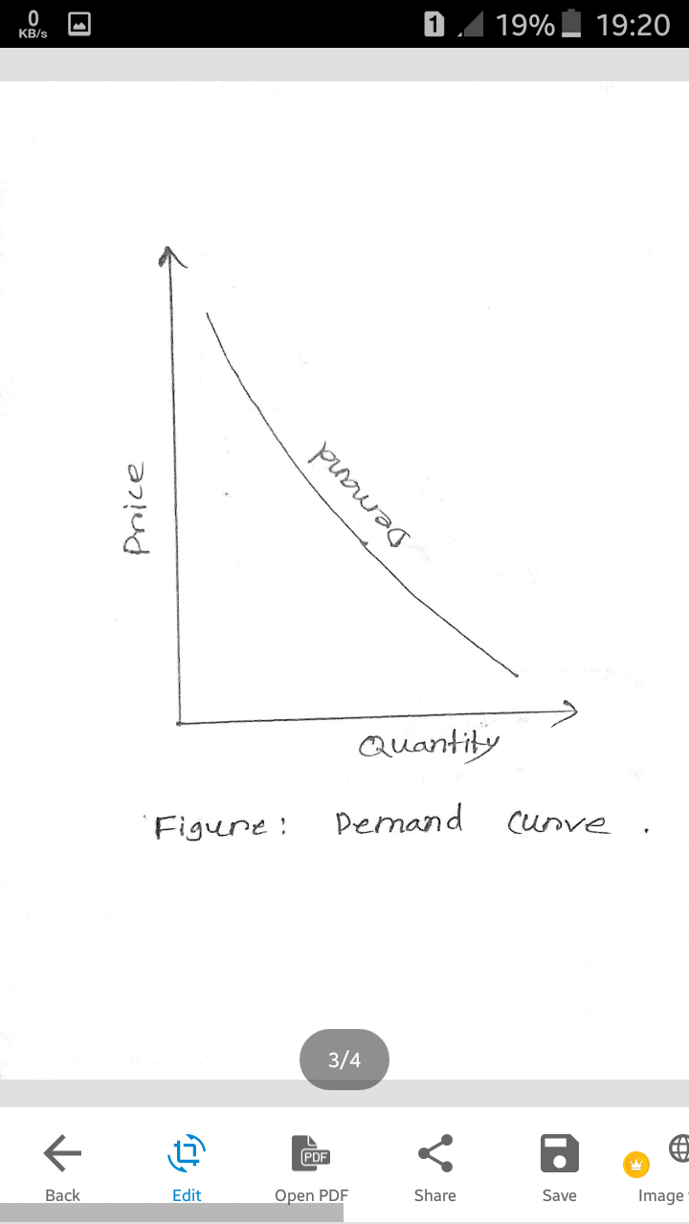

**Demand schedule and graph**

|  |  |
| --- | --- |
| **Price of Product X (taka)** | **Quantity demand (kg)** |
| **15** | **20** |
| **20** | **10** |
| **25** | **6** |
| **30** | **4** |
| **35** | **2** |

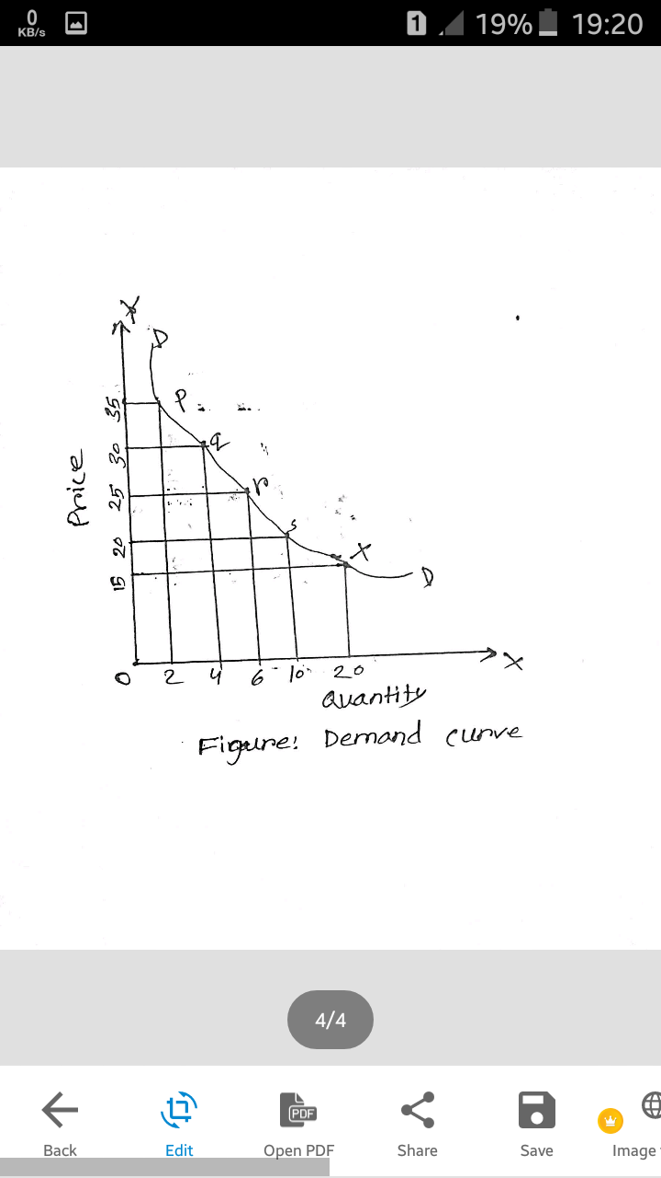

In Figure, the DD curve represents the demand curve of product X.